TASK:

Now **vary the packet size and observe the metrics**. Take packet size [128,256,512,1024,2048] bytes and collect the throughputs for each of them. Plot the packet size vs Throughput in this case and explain the graph.

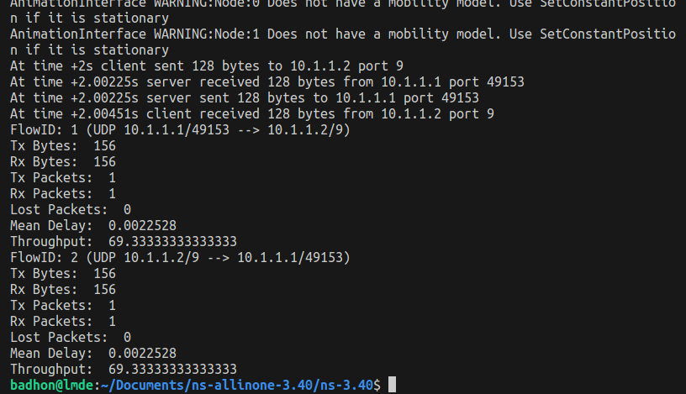

**Image of packet size 128**

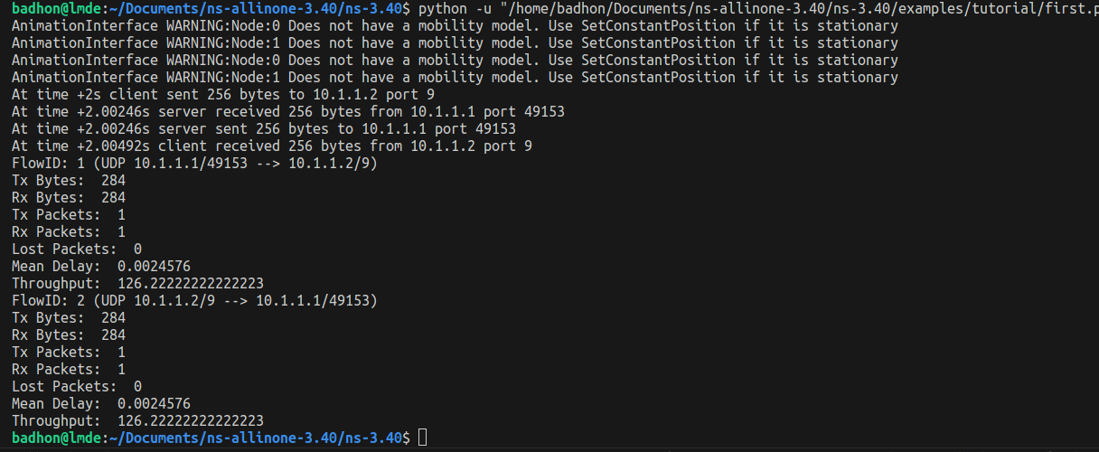

**Image of packet size 256**

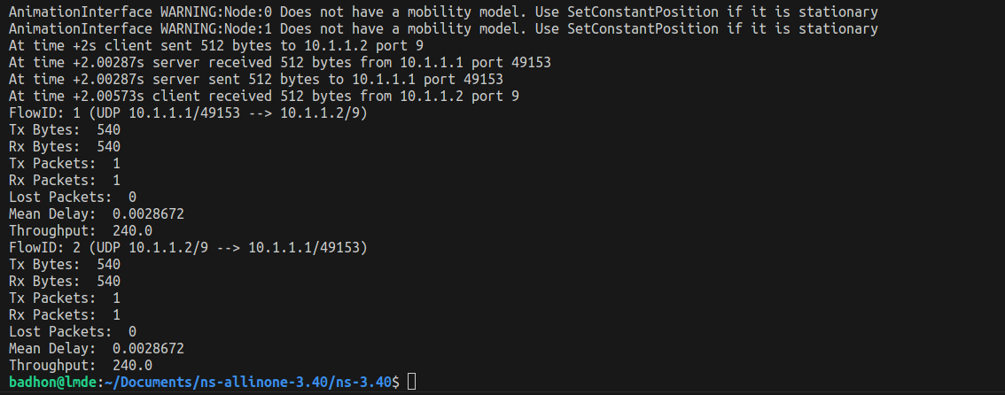

**Image of packet size 512**

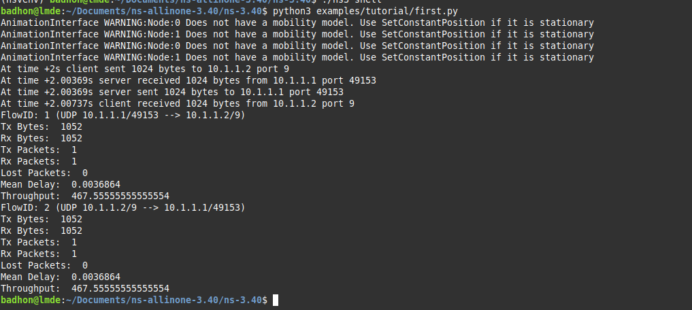

**Image of packet size 1024**

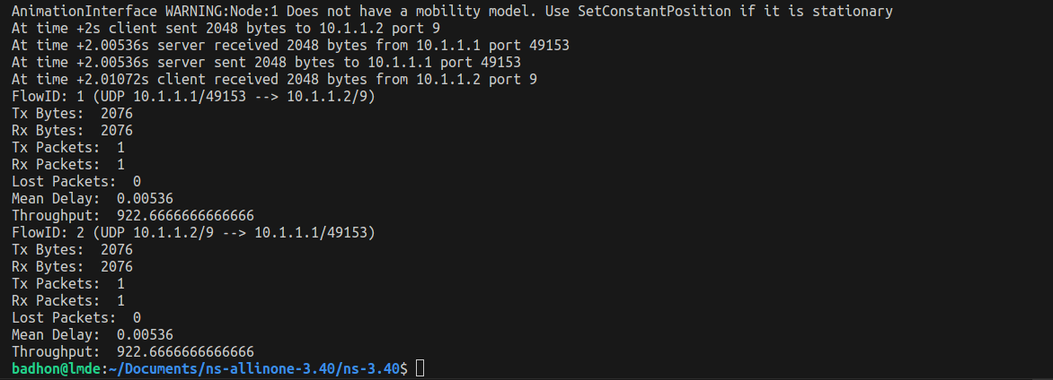

**Image of packet size 2048**

Here, the X axis will be packet, and the Y axis will be throughput. So the coordinates will be (128, 69.33), (256, 126.22), (512, 240), (1024, 467.56), and (2048, 922.67).

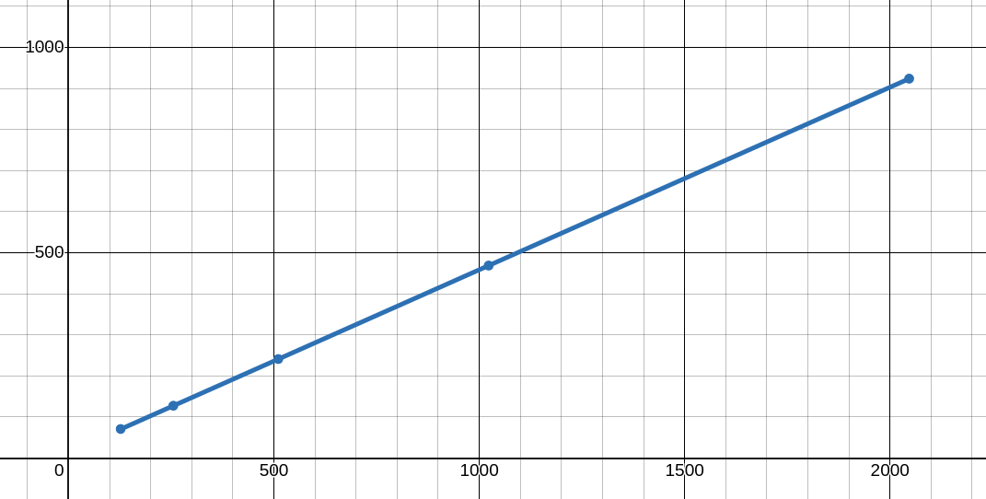

This graph shows throughput increases with the packet size. It’s an increasing graph by nature. The graph illustrates the relationship between packet size (X-axis) and throughput (Y-axis). It demonstrates that as the packet size increases, the throughput also increases. The data points, plotted at (128, 69.33), (256, 126.22), (512, 240), (1024, 467.56), and (2048, 922.67), form a steadily rising curve. This indicates that larger packets allow for more data to be transferred per unit of time, leading to higher throughput. The graph’s increasing nature reflects the efficiency gain with larger packet sizes due to reduced overhead per unit of data transmitted. However, this trend may eventually plateau or face diminishing returns at even larger packet sizes due to network constraints like latency or fragmentation limits.

END